# WorkGraphIQ (WGI): The Evidence-Based Operating System for Process Intelligence

## Executive Summary: Engineering the Foundation of Fact

The contemporary enterprise stands at a precipice of transformation, compelled by the promise of artificial intelligence to reimagine its operating models. Yet, a fundamental paradox obstructs this ambition: organizations possess an abundance of process documentation but a scarcity of process *truth*. Strategic decisions regarding automation, digitization, and organizational redesign are frequently predicated on static artifacts—aspirational process maps generated in workshops, fragmented system logs that lack context, and the subjective recall of subject matter experts. This reliance on incomplete approximations leads to the "Optimization Trap," where tasks are automated locally in a manner that inadvertently fractures value creation globally.

We are shifting the paradigm from delivering services based on estimation to engineering a self-adapting operating system for value creation based on a **Foundation of Fact**. This report defines the comprehensive blueprint for **WorkGraphIQ (WGI)**, a platform-driven approach orchestrated by a temporal Work Reality Graph and powered by Agentic AI. WGI does not merely observe work; it reconstructs it through a rigorous, multi-plane synthesis of evidence.

Unlike traditional process mining, which is constrained by the boundaries of system logs, or task mining, which is limited to desktop observation, WGI integrates **three simultaneous evidence planes** into a single, reconciled "Decision Twin." These planes—**Work-Surface Reality** (endpoint behavior), **System-Recorded Reality** (logs and telemetry), and **Human-Perceived Reality** (qualitative input)—are continuously ingested, correlated, and validated. This triangulation ensures that the resulting model accounts for the rigid transactional truths of the ERP system, the fluid behavioral truths of the desktop user, and the tacit contextual truths known only to the human expert.

This model transforms intellectual property into executable workflows, ensuring that every practitioner delivers consistent, high-quality outcomes through a "paint-by-numbers" engine that embeds expert methodology directly into the daily workflow. By standardizing the process into a strict six-phase lifecycle, we reduce the "setup time" for new projects, enforce rigorous quality gates, and utilize AI to move from content creation to content validation. Furthermore, WGI enforces a discipline of **Bright, Dim, and Dark** knowledge. The system does not hallucinate certainty; it treats uncertainty as a managed object—a "Dark Room" of operational ambiguity—that must be systematically illuminated through targeted, AI-mediated human validation.

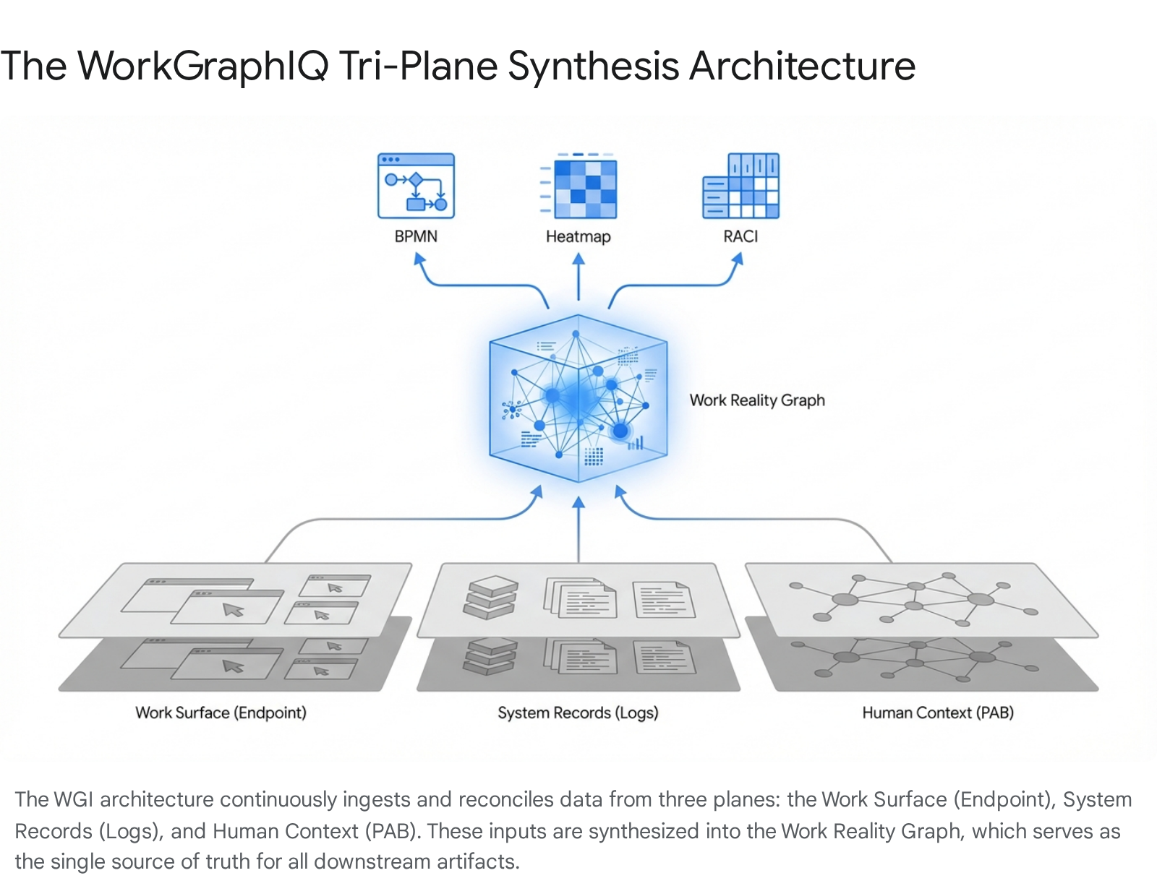

## 1. Project Onboarding & Team Activation (The "Zero Phase")

Before the formal project lifecycle begins, a rigorous **Onboarding & Activation** protocol ensures that every team member enters the engagement with a unified understanding of the client context and the delivery methodology. This automated "Zero Phase" replaces the traditional ad-hoc email chains and manual file sharing with a structured digital entry point. It creates a deterministic environment where governance, privacy, and scope are established as machine-enforceable configurations rather than loose agreements.

### The Automated Onboarding Workflow

Trigger & Allocation:

Once the Statement of Work (SOW) is signed and Resource Management allocates specific individuals to the engagement, the Business Process Management (BPM) system triggers an automated workflow. This action initializes the Engagement Workspace, a bounded container that encapsulates the process scope (e.g., "Order-to-Cash," "IT Incident Resolution"), participant roles, and time windows.1

Tenant Provisioning and Isolation:

To satisfy the rigorous security requirements of Fortune 500 enterprises, WGI mandates strict tenant isolation. The onboarding workflow triggers the provisioning of a dedicated Tenant Workspace. This is not merely a folder structure but a logical and physical data boundary. The system configures the workspace based on the client’s specific infrastructure requirements, selecting from three supported deployment modes:

* **Cloud Mode:** Control plane and tenant data planes are hosted, with connectors running in the cloud or via client-controlled collectors depending on network constraints.
* **Hybrid Mode:** The control plane is hosted, but the data plane ingestion requires on-premise connector collectors to pull internal logs and endpoints uploading via private connectivity.
* **On-Prem Mode:** The entire stack is deployed within the client environment (e.g., Kubernetes), ensuring an air-gapped execution where data never leaves the client's perimeter.1

Identity Integration & Role Mapping:

To strictly avoid the surveillance trap and focus on process truth, WGI defaults to role-level rather than individual-level analysis. The onboarding workflow triggers a read-only integration with the client’s Enterprise Identity Provider (IdP) (e.g., Azure AD, Okta, Ping Identity). The system ingests directory attributes to populate the internal identity graph.

* **Role Mapping Strategy:** The system applies a configurable strategy to map raw user identifiers (stored internally as a pseudonymous user_ref) to stable role_ref buckets. This ensures that analysis focuses on the "Claims Adjuster" cohort rather than "Jane Doe." The mapping logic supports:
  + **Attribute-based mapping:** Using job codes, titles, or organizational units.
  + **Group-based mapping:** Leveraging directory group memberships.
  + **HR Feed mapping:** Integrating with job family tables.
  + Manual Pilot mapping: For smaller, targeted initial runs.  
    Crucially, this mapping is versioned. If organizational structures change during the project, historical data remains interpretable against the role definitions that existed at the time of capture.1

### Governance & Privacy Configuration

The Policy Bundle Definition:

Before a single byte of data is captured, the Engagement Operator must define the Endpoint Policy Bundle. This is a machine-enforceable configuration object that dictates the precise behavior of the capture agents. It serves as the digital contract between the WGI platform and the client's security/privacy councils. The bundle defines:

* **Scope Definition:** The operator defines "In-Scope" applications (allowlist) and "Out-of-Scope" applications (blocklist). The system enforces these rules at the agent level, ensuring that personal or sensitive applications (e.g., banking sites, personal email, healthcare portals) are mathematically excluded from the capture stream.
* **Capture Primitives Configuration:** The operator toggles the specific capture modes based on the agreed privacy posture:
  + **Focus Sessions:** Enabled by default to track application usage time and window focus duration.
  + **Interaction Counts:** Enabled to track intensity (clicks, scrolls, keystroke counts) without capturing content. WGI strictly prohibits keystroke logging by default.
  + **Visual Context Events (VCE):** Configured with strict triggers (e.g., "High Dwell Time," "Error State") to capture metadata about screen states without continuous recording.
  + **Screenshot Retention:** Defaulted to **OFF**. If enabled for specific high-value ambiguity resolution, it is coupled with mandatory on-device redaction and short retention windows.1

Consent & Transparency Architecture:

The onboarding phase establishes the Consent Model (Opt-in, Org-Authorized, or Hybrid). The system generates a transparency statement for end-users, accessible via the Desktop Widget, explaining exactly what is—and is not—being captured.

* **Consent Record:** The system creates an immutable ConsentRecord for each participant, linking their user_ref to the specific policy_bundle_version they acknowledged. This ensures auditability of consent throughout the engagement lifecycle.1

### Readiness Gating

The Capture Readiness Gate:

The system enforces a hard logic gate before transitioning to Phase 1. The Readiness Checklist validates that the environment is safe and functional before data flows. The system checks:

1. **Endpoint Health:** Agents are deployed, heartbeating, and policy bundles are successfully downloaded to the fleet.
2. **Connector Access:** Service accounts for system logs have been validated with least-privilege access (Read-Only).
3. Identity Map: A minimum threshold of users (e.g., >80%) has been successfully mapped to roles, ensuring analytical validity.  
   Only when these boolean checks pass does the system unlock the "Capture Active" status, allowing the team to proceed to Mobilize & Governance.1

## 2. Phase 1: Mobilize & Governance (Automated Initiation)

### Purpose

The primary purpose of the **Mobilize & Governance** phase is to transition from a signed contract and configured environment to a fully operational program structure with zero friction. In traditional models, this "spin-up" period is often chaotic, reliant on manual document creation and subjective alignment. In this next-generation model, the objective is to rewire leadership thinking immediately and establish a "North Star" for the transformation using hard data rather than opinion. This phase establishes the digital "chain of custody" for the project, activating the **Work Capture Plane** to begin the parallel ingestion of evidence from all three sources.2

### Detailed Activities

**Activation of the Work Capture Plane:**

* **Desktop Agent Launch:** The Program Manager triggers the "Start Capture" command via the central console. The endpoint agents, previously in a dormant "heartbeat-only" state, begin buffering and uploading **Focus Sessions** and **Interaction Slices** according to the Policy Bundle. The Desktop Widget on client machines transitions to "Active," providing users with visible feedback and pause controls.1
* **Connector Instantiation:** The system activates the **Connector Runners**. These agents begin the incremental extraction of system logs. WGI employs a "Best-in-Class" connector framework designed for enterprise scale:
  + **Connector Category A (SaaS/Enterprise Apps):** Extracts lifecycle transitions, assignments, and audit changes from systems like Salesforce, ServiceNow, and SAP.
  + **Connector Category B (Database/Data Platforms):** Ingests operational tables or curated event views from Snowflake or Databricks.
  + **Connector Category C (Integration Telemetry):** Captures correlation IDs and transaction logs from API gateways and middleware to stitch cross-system flows.
  + **Connector Category D (Observability):** Ingests service traces (OpenTelemetry) to map automated system steps.
  + **Connector Category E (Agent Runtime):** Captures tool calls and orchestration spans from AI agents.1

The Process Assessment Bot (PAB) - Pre-Run Hypothesis Mode:

Simultaneously, the system deploys the Process Assessment Bot (PAB) to the human cohort. Unlike a passive survey, the PAB operates in "Hypothesis Mode" (Day 0–2). Its goal is to capture the human perception of the process before the telemetry data begins to flow.

* **Inquisitive Boundary Setting:** The bot engages Subject Matter Experts (SMEs) to define the *perceived* process boundaries. It asks structured questions to establish:
  + **Process Boundaries:** "Where does this process truly start (e.g., customer email vs. ticket creation)?"
  + **Perceived Hotspots:** "Where do you believe the most friction exists?"
  + **Dark Room Initialization:** "What happens that is not recorded in any system?"
* **Structured Claim Generation:** The bot converts these responses into **Survey Claim Objects**—structured data entities that record the claim, the certainty tier ("Known" vs. "Suspected"), and the proof expectation ("You would see this in the email logs"). This seeds the "Dark Room" backlog with initial hypotheses.1

Schema Intelligence Application:

The system applies its Schema Intelligence Library to the incoming data streams. It automatically detects standard enterprise schemas (e.g., an SAP "Order" object or a Jira "Issue" lifecycle) and proposes a preliminary mapping to the canonical Activity Taxonomy. This reduces the "time-to-meaning" by applying pre-built extraction templates and correlation recipes to raw logs, accelerating the path to a coherent event spine.1

### Deliverables & Input/Output Logic

**Deliverable:** **Digital Program Charter & Governance Structure.**

* **Specific Input:** The Statement of Work (SOW) contract details and the AI-generated Organizational Baseline data (role maps).
* **Specific Output:** This Charter is the mandatory input for the Phase 2 Stakeholder Analysis. The defined roles in the Charter populate the "Approver" fields in the BPM workflows for all subsequent phases.2

**Deliverable:** **Initial "Dark Room" Backlog & Hypothesis Map.**

* **Specific Input:** Structured responses from the PAB's Pre-Run Hypothesis Mode.
* **Specific Output:** A prioritized list of "Known Unknowns" (e.g., "We suspect manual handoffs occur here but lack data"). This backlog feeds the **Phase 2 Reconciliation Engine**, directing it to look for evidence that supports or refutes these human claims.1

**Deliverable:** **Connector Health & Lineage Dashboard.**

* **Specific Input:** Telemetry from Connector Runners and Endpoint Agents.
* **Specific Output:** A live view of data ingestion health. This serves as the input for **Phase 2 Data Quality Checks**, ensuring that the synthesis engine is not fed corrupted or partial data.1

### Team Workflow & Communication Strategy

* **Internal Routing:** The Platform Operator monitors the **Ingestion Latency** and **Schema Drift** alerts. If a connector fails or a schema changes, an alert is routed immediately to the Data Engineer for remediation.
* **Client Socialization:** The "Hypothesis Map" is presented to the Client Sponsor to confirm that the WGI scope aligns with their strategic intent. This aligns expectations before the "hard data" potentially contradicts their assumptions.

## 3. Phase 2: Diagnostic & Strategy (The Synthesis Engine)

### Purpose

The **Diagnostic & Strategy** phase is the analytical heart of the lifecycle. Its purpose is to move beyond "gut feeling" to a predictive, data-driven change strategy. By synthesizing data on **Impact** (what is changing), **Stakeholders** (who is changing), and **Readiness** (capacity to change), the team formulates a strategy that is mathematically tailored to the organization's risk profile. This phase deploys the **Reconciliation Engine** to synthesize the three evidence planes—Endpoint, System, and Human—into a coherent **Work Reality Graph**. It validates the feasibility of the hypotheses generated in Phase 1 and converts raw signals into a **longitudinal, case-centric event spine**.

### Detailed Activities

Construction of the Case-Centric Event Spine:

The Canonicalization Service transforms the raw normalized evidence from Phase 1 into Canonical Activity Events.

* **Normalization:** Raw system logs (e.g., "State changed from 1 to 2") are mapped to business activities (e.g., "Ticket Resolved") using the **Mapping Rule Set**.
* **Longitudinal Stitching:** The system groups events by **Case ID** (e.g., Order #123) to reconstruct the end-to-end timeline of a single unit of work. This creates the structural backbone of the process model.1

Multi-Plane Correlation & Linkage:

The Correlation Engine links the disparate evidence planes. This is the critical step that distinguishes WGI from simple process mining.

* **Deterministic Linkage:** Where possible, the engine links Endpoint Focus Sessions to System Cases using explicit identifiers (e.g., a window title containing "Order #123" captured via allowlisted extraction patterns). This creates a **Bright** link—high confidence.
* **Assisted Linkage:** Where identifiers are missing, the engine uses probabilistic features (Time Proximity + Role Match + System Context) to infer links (e.g., "User A was in SAP at 10:00 AM, and an SAP log was generated at 10:00 AM"). These are marked as **Dim** links, carrying a lower confidence score and requiring validation.
* **Role-Level Association:** When case linkage is not possible, the system associates endpoint evidence at the role level to quantify cross-system switching and time accumulation, explicitly marking these insights as "Aggregate" rather than case-specific.1

The Work Reality Graph Synthesis:

All correlated data is persisted into the Work Reality Graph, a temporal knowledge graph.

* **Node Creation:** The graph creates nodes for Cases, Activities, Roles, Systems, and—crucially—**Uncertainty Objects**.
* **Certainty Scoring:** The engine calculates a **Confidence Score** (0–1) for every edge and node based on the strength of evidence.
  + **Bright:** Supported by overlapping evidence (e.g., Log + Endpoint + Survey agreement).
  + **Dim:** Supported by single-source or weak correlation.
  + Dark: Evidence is missing or contradictory (e.g., Survey says "X happens," Logs show nothing).  
    This graph preserves the provenance of every data point, ensuring that the system can always answer "How do we know this?".1

Visual Context Event (VCE) Classification:

For "Dim" or "Dark" segments where logs are silent (e.g., high dwell time on a screen with no system interaction), the system analyzes captured Visual Context Events.

* **Metadata Extraction:** On-device models classify the screen state into categories like "Queue," "Search," "Data Entry," or "Error."
* **Ambiguity Resolution:** This metadata is injected into the graph to explain *why* time is accumulating. A 10-minute gap is no longer "Unknown Time"; it is classified as "10 minutes of Search Friction" or "5 minutes of Waiting Latency." This transforms unexplained gaps into actionable friction points.1

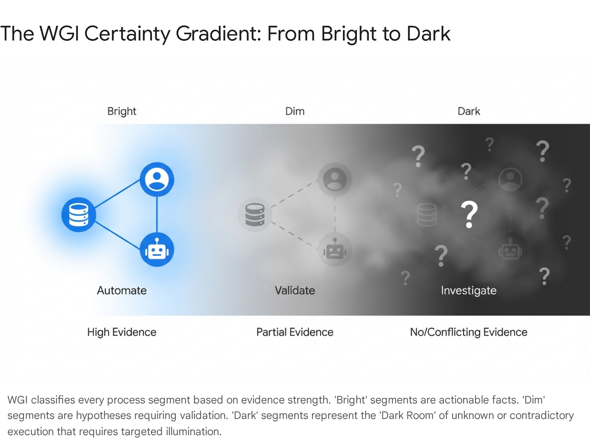

### Deliverables & Input/Output Logic

**Deliverable:** **Strategic Roadmap & Change Strategy.**

* **Specific Input:** The Stakeholder Sentiment Scores and the Change Saturation Score generated in the saturation analysis.
* **Specific Output:** This Strategy is the blueprint input for the Phase 3 Communication Plan and Training Curriculum. For example, a "High Resistance" score dictates a "High Touch" communication strategy in Phase 3.2

**Deliverable:** **The Work Reality Graph (Version 1.0).**

* **Specific Input:** Correlated events from the Correlation Engine and Survey Claims.
* **Specific Output:** The source-of-truth dataset that feeds the **Phase 3 Publishing Engine**. The graph structure ensures that no downstream artifact can be generated without traceable provenance.1

**Deliverable:** **Diagnostic Heat Map & Friction Report.**

* **Specific Input:** Time accumulation data from the Graph (Cycle Time, Wait Time, Residual Time).
* **Specific Output:** A quantified view of "Where time goes." This report highlights **Hotspots** (e.g., "Step 4 accumulates 40% of cycle time due to 'Search' behavior"). This data drives the **Phase 3 Scenario Design**, focusing redesign efforts on the highest-value friction points.1

### Team Workflow & Communication Strategy

* **Internal Routing:** The "Synthesis Engine" runs continuously. The Process Analyst reviews the **Correlation Quality Dashboard**. If "Residual/Unknown Time" exceeds a threshold (e.g., >20%), the analyst triggers a **PAB Micro-Survey** to illuminate the gap before proceeding.
* **Client Socialization:** The Diagnostic findings are not just emailed. They are presented in a **"Truth Verification" session**. The team shows the "Dark Room" metrics to the client, managing expectations that "we have found 80% of the truth; the remaining 20% requires your validation in Phase 4."

## 4. Phase 3: Planning & Design (Generative Construction)

### Purpose

The **Planning & Design** phase shifts the focus from analysis to creation. The purpose is to design the specific interventions—communications, training, and sponsorship activities—that will bridge the gap between the current and future states. In this AI-orchestrated model, the heavy lifting of "drafting" is handled by Generative AI, allowing the consulting team to focus on "refining" and "strategizing." This ensures that plans are not generic templates but are hyper-personalized to the insights gathered in Phase 2. Additionally, this phase leverages the **Scenario Studio** to generate AI-enabled future-state options.2

### Detailed Activities

Generative Artifact Creation:

The Publishing Engine queries the Work Reality Graph to auto-generate the core components of the Process Evidence Pack.

* **BPMN 2.0 Generation:** The engine exports the "Happy Path" and top variants into standard BPMN 2.0 XML. Crucially, it embeds **Confidence Metadata** directly into the model nodes. **Dark** segments are rendered as explicit "Unknown Subprocess" placeholders or grouped subprocesses, rather than inventing steps to force connectivity.
* **Derived RACI Matrix:** The system analyzes role-based interaction patterns to generate a *Proposed* RACI. It identifies the "Responsible" party based on execution frequency and the "Accountable" party based on approval patterns. These cells are marked "Proposed" (Dim) pending validation.
* **Narrative Generation:** Large Language Models (LLMs) ingest the graph data (event sequences, role interactions, friction points) to write human-readable **Narrative Workflows**.
  + *Narrative A:* "The Happy Path" – a clear story of the standard process.
  + *Narrative B:* "The Variants & Exceptions" – a detailed account of edge cases and rework loops.
  + *Embedded Validation:* The LLM automatically inserts **Validation Prompts** into the text where confidence is low (e.g., "* appears to be used here, but logs are inconclusive. Is this correct?*").1

Scenario Studio & Active Inferencing:

The Scenario Studio module uses Agentic AI to propose future-state designs based on the diagnostic data.

* **Efficiency Scenarios:** The AI identifies "Repetitive Mechanical Work" (high interaction count, low variability) and proposes automation candidates (e.g., "Automate data entry at Step 5 via RPA").
* **Reimagination Scenarios:** The AI looks for structural inefficiencies (e.g., "Ping-pong handoffs between Role A and B") and proposes **Operating Model Redesigns** (e.g., "Consolidate Role A and B into a single Case Manager").
* **Constraint Checking:** Active Inferencing algorithms score these scenarios against an **Assessment Overlay**.

The Assessment Overlay Matrix:

The Assessment Overlay evaluates every proposed scenario against two critical axes to prioritize the roadmap: Business Value and Ability to Execute.

* **Business Value:** This dimension aggregates observable data such as cycle time reduction, cost-to-serve savings, and error reduction rates. The system calculates potential value based on the frequency of the friction point and the burden rate of the roles involved.
* **Ability to Execute:** This dimension assesses complexity and dependency. It scores factors like:
  + **Adjacency Involvement:** How many distinct teams (IT, Security, HR, Data) must coordinate?
  + **Technical Complexity:** Does this require new integrations or merely configuration?
  + **Data Readiness:** Is the necessary data available and clean?
  + Change Impact: How significant is the reskilling requirement?  
    The system plots these scenarios on a matrix, clustering them into categories such as "Quick Wins" (High Value, High Ability) versus "Strategic Bets" (High Value, Low Ability).1

### Deliverables & Input/Output Logic

**Deliverable:** **Master Enablement Plan.**

* **Specific Input:** The approved Change Strategy from Phase 2 and the Project Schedule from the technical team.
* **Specific Output:** This plan acts as the configured "Script" for the Phase 4 Execution Engine. The BPM system uses this plan to auto-schedule email blasts and training invites.2

**Deliverable:** **The Process Evidence Pack (Draft).**

* **Specific Input:** The Work Reality Graph and the outputs of the Publishing Engine.
* **Specific Output:** A comprehensive bundle containing the BPMN XML, Swimlanes, RACI, and Narratives. This pack is the input for the **Phase 4 Validation Hub**. It is explicitly labeled "Draft v1.0 - Pending Validation".1

**Deliverable:** **Future-State Roadmap Options.**

* **Specific Input:** The Scenario Studio outputs and Assessment Overlay scores.
* **Specific Output:** A prioritized list of transformation opportunities. This serves as the strategic menu for the **Executive Playback** session.1

### Team Workflow & Communication Strategy

* **Internal Routing:** The Program Manager reviews the generated artifacts for "hallucinations." Although the system is grounded in data, human oversight ensures the narrative tone is appropriate.
* **Client Socialization:** The "Draft" Evidence Pack is released to the **Client Portal**. SMEs receive notifications that their specific process segments are ready for review. This triggers the transition to Phase 4.

## 5. Phase 4: Execute & Enablement (Orchestrated Delivery)

### Purpose

The **Execute & Enablement** phase is where the plans are activated. In the WGI lifecycle, this refers to the execution of the **Validation Loop**. The purpose is to build Knowledge and Ability (ADKAR) at scale while monitoring the organization's pulse in real-time. This phase orchestrates the interaction between the **Process Assessment Bot** and the human experts to "shrink the Dark Room," converting the "Draft" baseline (populated with Dim and Dark segments) into a "Validated" baseline (Bright). This creates the consensus required for the final Go/No-Go decision on the transformation roadmap.2

### Detailed Activities

Orchestrated Validation & Micro-Nudges:

The Validation Hub decomposes the Process Evidence Pack into "Segment-Level Review Packs."

* **Targeted Routing:** The PAB routes specific questions to specific roles. A "Claims Adjuster" is asked only about the claims adjustment step, not the entire end-to-end process.
* **Micro-Nudges:** The bot issues targeted prompts via MS Teams or Slack: "*We see a 4-hour gap between Step A and Step B in 30% of cases. Is this typically due to (A) Waiting for Approval, (B) Data Error, or (C) Other?*"
* **Structured Feedback:** Responses are not free-text comments; they are structured data updates. Selecting "(A) Waiting for Approval" automatically updates the graph, converting a "Dark Gap" node into a "Dim Waiting" node.1

Replay-Based Validation:

To build trust, WGI deploys the Replay Visualization Engine.

* **Visual Evidence:** Instead of asking SMEs to validate a static diagram, the system plays back the **Aggregate Volume Replay**. SMEs watch the flow of work (represented as particles or volumes) moving through the system.
* **Accumulation Verification:** They can visually see work piling up at "Step 4." This "seeing is believing" moment validates the **Hotspots** derived in Phase 2. SMEs confirm: "Yes, that is exactly where the backlog happens".1

Go-Live Readiness Gating (The "Truth Gate"):

The phase culminates in a Validation Threshold Check.

* **Dark Room Shrink Rate:** The system calculates the percentage of "Dark" time remaining in the model.
* **Gating Logic:** If the "Dark Room" size exceeds the agreed threshold (e.g., >10%), the system prevents the roadmap from being finalized. It triggers a "Validation Sprint" to resolve the remaining ambiguity.
* **Readiness Dashboard:** The team conducts the final readiness assessment. The BPM system aggregates data from Training (Attendance), Comms (Open rates), and Tech (UAT pass rates) into a single dashboard.1

### Deliverables & Input/Output Logic

**Deliverable:** **Readiness Dashboard & "Go/No-Go" Recommendation.**

* **Specific Input:** Real-time data streams: Training Attendance Logs, Communication Open Rates, and UAT Pass Rates.
* **Specific Output:** This decision dictates the Technical Deployment Trigger. A "No-Go" result halts the technical release, preventing a failed launch.2

**Deliverable:** **Validated Process Evidence Pack (v2.0).**

* **Specific Input:** Structured feedback from the PAB Validation Loop and Replay sessions.
* **Specific Output:** A "Bright" baseline model. The "Proposed" RACI becomes "Validated." The "Draft" BPMN becomes "Baseline." This artifact is the mandatory input for **Phase 5 Adoption Baseline**.1

**Deliverable:** **Validation Log & Uncertainty Report.**

* **Specific Input:** Audit logs of every validation action (who confirmed what).
* **Specific Output:** A defensible audit trail proving that the process model is not an analyst's opinion but a consensus view of the organization.1

### Team Workflow & Communication Strategy

* **Internal Routing:** The Validation Hub acts as the "Command Center." The Program Manager monitors the **Validation Completion Rate**. If a specific department is unresponsive, the system flags a bottleneck, allowing the PM to intervene.
* **Client Socialization:** The "Validated Baseline" and the "Future State Roadmap" are presented to the **Steering Committee**. The visual power of the Replay and the rigor of the Validation Log provide the confidence needed to approve the investment.

## 6. Phase 5: Adoption & Sustainability (The Self-Correcting Loop)

### Purpose

The **Adoption & Sustainability** phase focuses on the period *after* the initial baseline is established and the transformation roadmap is approved. Its purpose is to prevent "backsliding" and ensure the new behaviors stick. This phase utilizes the system to measure **proficiency**, not just **usage**, and transitions WGI from a "Project Tool" to an "Operational Monitor." The system continuously ingests data to measure **Drift** (deviation from the validated baseline) and **Adoption** (movement toward the future state), ensuring that the "Foundation of Fact" remains current.2

### Detailed Activities

Drift Detection & Continuous Reconciliation:

The Work Reality Graph does not freeze; it continues to ingest data from the Work Capture Plane.

* **Baseline Monitoring:** The system compares live execution paths against the **Validated Baseline (v2.0)** established in Phase 4.
* **Drift Alerting:** If the system detects a new variant (e.g., "Users are bypassing Step 3"), it triggers a **Drift Alert**. This is not just a notification; it creates a new "Uncertainty Object" in the graph, potentially triggering a PAB micro-survey to ask: "*We see a new process path. Is this an approved workaround?*".1

Adoption Tracking (Proficiency vs. Usage):

For initiatives where the "Future State" is being deployed, WGI measures adoption using evidence, not surveys.

* **Behavioral Verification:** The system tracks whether the *new* behaviors (e.g., using the new tool, following the new sequence) are appearing in the telemetry.
* **Outcome Correlation:** It correlates adoption rates with outcome metrics (e.g., "Teams adopting the new path have reduced cycle time by 20%"). This proves the value of the change in real-time.
* **Behavioral Reinforcement Loops:** The system identifies "Super Users" who are adopting the change fastest and prompts leadership to recognize them publicly. It also identifies "Laggards" and schedules 1:1 coaching sessions for their managers.2

Transition to Business As Usual (BAU):

The engagement team hands over the WGI Console to the client's Center of Excellence (CoE) or Process Owners.

* **Asset Handoff:** The "Process Evidence Pack" becomes a living asset in the client's repository.
* **Self-Correction:** The client is trained to use the **Validation Hub** to manage future drift and keep the model "Bright".1

### Deliverables & Input/Output Logic

**Deliverable:** **Drift & Adoption Dashboard.**

* **Specific Input:** Real-time streams from the Work Capture Plane vs. the Validated Baseline.
* **Specific Output:** A live view of process stability. This feeds the **Phase 6 ROI Calculation**.1

**Deliverable:** **Living Process Twin.**

* **Specific Input:** The continuously updated Work Reality Graph.
* **Specific Output:** A dynamic asset available for query by the client's enterprise architecture or automation teams.1

### Team Workflow & Communication Strategy

* **Internal Routing:** The team shifts from "Discovery" to "Monitoring." The Program Manager reviews drift trends weekly. The focus is on "Hypercare"—resolving adoption barriers identified by the system.
* **Client Socialization:** Weekly "Adoption Pulse" reports are sent to Department Heads, showing exactly which teams are adopting the change and which are backsliding, using data to drive accountability.

## 7. Phase 6: Evaluate, Innovate & Close (Wisdom Harvesting)

### Purpose

The final phase, **Evaluate, Innovate & Close**, answers the question: "Did we achieve the value?" Its purpose is to calculate the final ROI using the hard data collected in Phase 5, capture lessons learned ("Wisdom Harvesting"), and update the central WGI intelligence banks. This closes the loop, ensuring that every engagement makes the WGI platform smarter for the next one. It transforms the project from a one-off event into a continuous improvement loop.2

### Detailed Activities

Value Realization Calculation:

The system performs a mathematical comparison of the Phase 1 Hypothesis vs. the Phase 4 Baseline vs. the Phase 5 Actuals.

* **Quantifiable ROI:** "We identified 20% friction (Phase 2). We designed a solution to remove it (Phase 3). Adoption data shows 15% reduction in cycle time (Phase 5). Value = 15% * Cost Per Transaction."
* **Outcome Efficacy:** Verifying if the behavioral changes actually drove the desired business outcomes (e.g., revenue increase, CSAT improvement).1

Wisdom Harvesting (Schema & Pattern Updates):

The AI analyzes the engagement metadata to refine the central platform assets.

* **Schema Intelligence Update:** If the team built a new connector mapping for a custom system, that template is anonymized and added to the **Schema Intelligence Library**.
* **Pattern Extraction:** If a specific "Reimagination Scenario" (e.g., "AI-Agent Handoff") proved highly effective, it is added to the **Scenario Studio** library as a recommended pattern for future similar clients.
* **Vector Database Update:** Proven Patterns (what worked) and Anti-Patterns (what failed) are uploaded to the firm's central vector database.1

**Project Closure & Archival:**

* **Governance Teardown:** The Engagement Workspace is transitioned to "Closed" or "Archived" status based on the retention policy. Access rights are revoked or transferred to the client.
* **Evidence Deletion:** Raw capture data (if required by policy) is purged, leaving only the aggregated insights and models.
* **Client Offboarding:** The final learning module focuses on client offboarding and relationship preservation, ensuring the team leaves on a high note that encourages future business.1

### Deliverables & Input/Output Logic

**Deliverable:** **Final Value Realization Report.**

* **Specific Input:** Phase 1 Baselines vs. Phase 5 Actuals.
* **Specific Output:** The definitive "Proof of Value" document used by the Client Sponsor to report to the Board.2

**Deliverable:** **Updated Intelligence Libraries.**

* **Specific Input:** Successful mappings, patterns, and survey questions from the engagement.
* **Specific Output:** Updates to the central Schema Intelligence Library and PAB Prompt Library.1

### Team Workflow & Communication Strategy

* **Internal Routing:** The team conducts a "Retrospective" facilitated by the WGI system metrics (e.g., "Which phase took longest?").
* **Client Socialization:** The Final Value Report is presented in a "Victory Lap" session. This solidifies the partnership and often sets the stage for the next scope of work (e.g., "Now that we fixed Order-to-Cash, let's look at Procure-to-Pay").

## 8. Orchestration & Transparency: The BPM/AI Handoff Layer

This operating system relies on a sophisticated orchestration layer that ensures the "Foundation of Fact" is built systematically. It facilitates seamless handoffs between the Evidence Planes, the Graph, and the Publishing Engine, creating a transparent "Glass Box" experience for the client.

### 8.1 Facilitating The Handoffs (The "Baton Pass")

In WGI, data handoffs are "lossless" because they are mediated by the **Work Reality Graph** and enforced by the **Policy Decision Point (PDP)**.

* **Hard Logic Gates:** The PDP prevents the system from generating artifacts (Phase 3) until the Data Quality Checks (Phase 2) are passed. The system cannot "Publish" until "Reconciliation" is complete.
* **Data Inheritance:** When Phase 2 closes, the **Scenario Studio** (Phase 3) automatically inherits the "Hotspots" identified in the Graph. No analyst has to copy-paste friction points into a slide deck; the AI agents read the graph directly to generate solution scenarios.
* **The "Context Window" Transfer:** As the engagement moves from "Capture" to "Validate," the PAB inherits the "Dim" segments from the Graph. Its "Context Window" is populated with the specific ambiguities it needs to resolve, ensuring the bot asks relevant questions.1

### 8.2 End-to-End Transparency (The "Glass Box")

WGI replaces the "Black Box" of consulting with a "Glass Box" approach.

* **The Client Portal:** Clients have access to a live view of the **Work Reality Graph** (role-filtered). They can see the "Dark Room" shrinking in real-time.
* **Bottleneck Analysis:** The Program Manager sees a "Flow Analysis" of the Validation Loop. If a specific SME is holding up the "Go-Live" decision by failing to validate their segment, the system flags this operational bottleneck.
* **Velocity Tracking:** The system tracks the "Truth Velocity"—how fast are we converting Dark to Bright? This allows for proactive management of the engagement timeline. 2

### 8.3 Policy & Governance (The Trust Infrastructure)

WGI implements governance not as a policy document, but as enforceable platform behavior via the **Policy Decision Point (PDP)** and **Policy Enforcement Points (PEPs)**.

* **Architecture:** WGI utilizes an OPA-style (Open Policy Agent) architecture. The PDP evaluates every request against the active Policy Bundle.
  + **RBAC (Role-Based Access Control):** Enforces who can view what (e.g., only "Validation Leads" can close uncertainty items).
  + **ABAC (Attribute-Based Access Control):** Enforces data handling (e.g., "Mask User ID if Cohort Size < 5").
* **Audit Logging:** Every decision is logged. The Audit Log Service captures a complete taxonomy of events: Authentication, Policy Decisions, Evidence Access, Data Ingestion Lineage, and Validation Decisions. This creates a defensible audit trail that satisfies enterprise security and privacy councils.1

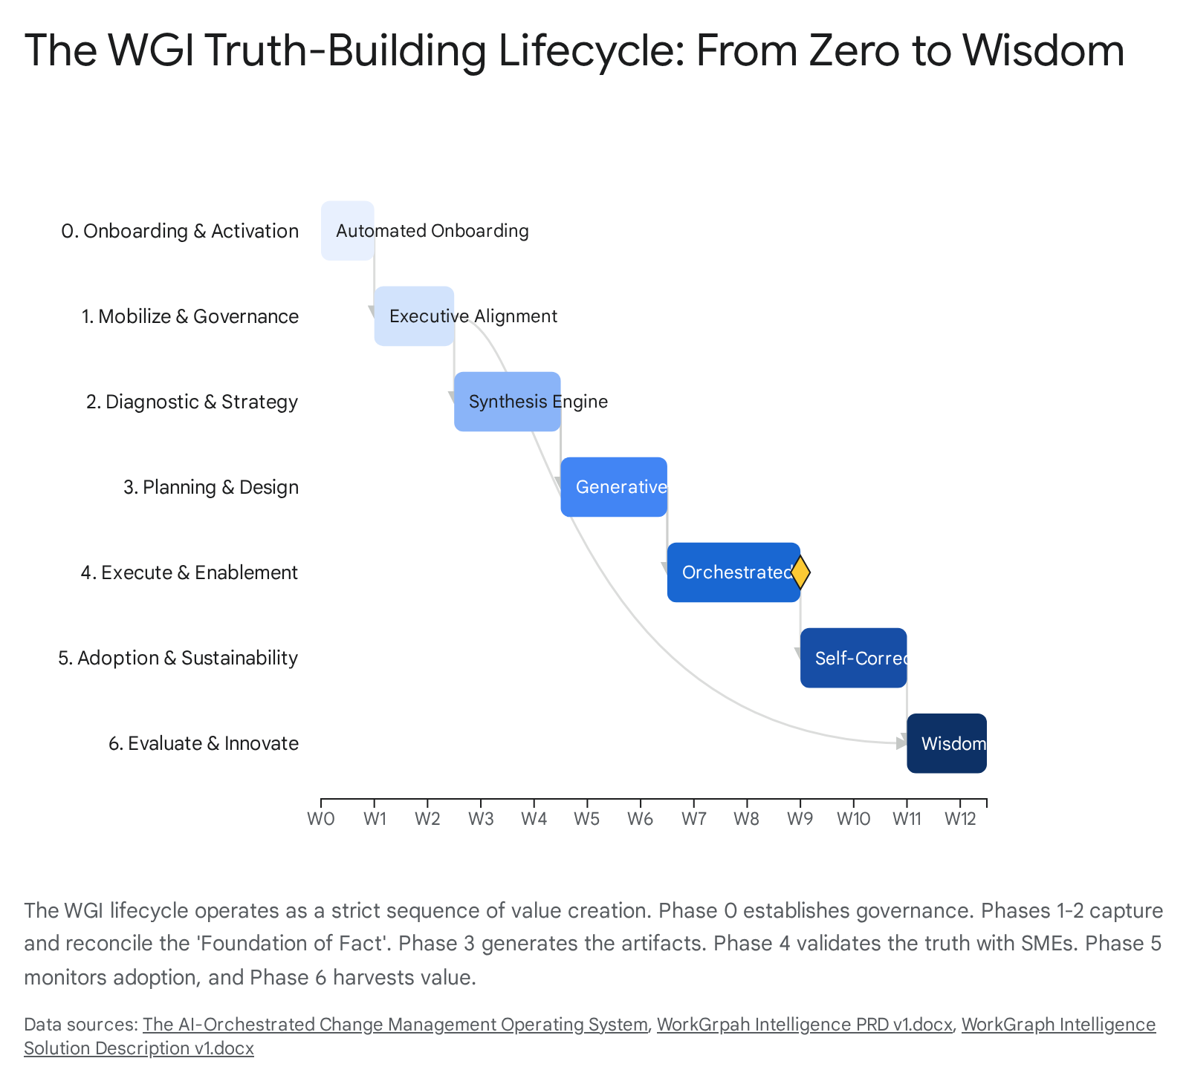

#### Works cited

1. WorkGrpah Intelligence PRD v1.docx
2. The AI-Orchestrated Change Management Operating System